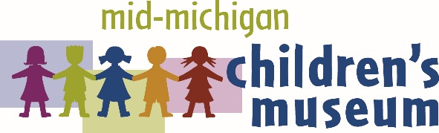
MEDIA RELEASE

CONTACT: Emily Yeager, President & CEO
315 W. Genesee Ave. I P.O. Box 2283
Saginaw, MI 48605
(989) 399-6626
eyeager@michildrensmuseum.com

FREE ADMISSION FOR BAY, MIDLAND AND SAGINAW
SECOND GRADE STEM FIELD TRIPS
SAGINAW, MI – January 17, 2017: Second grade students will learn the unique properties of air and water while enjoying gallery-play during 2nd Graders Are 1st Class field trips at the Mid-Michigan Children’s Museum (MMCM). Any public, parochial or charter school can schedule its admission-free second grade field trip today! Full-admission and limited transportation scholarships are generously provided through the Dow Corning Donor Advised Funds and S.C. Johnson & Son, Inc.
Mid-Michigan Children’s Museum’s A-Mazing Airways and Water, Water Everywhere galleries teach properties of air and water to second grade students in a fun, hands-on and interactive environment through a carefully-crafted learning experience that cannot be duplicated in a classroom setting. These STEM-based academic lessons align with Michigan Common Core standards.
The Mid-Michigan Children’s Museum is the only hands-on museum in our region created solely for children ages newborn through 10 years old. Each gallery is designed by children’s museum specialists and educators to ensure that children are educationally engaged as they play.
For more information about our 2nd Graders Are 1st Class initiative, please visit michildrensmuseum.com. To schedule a field trip for your second grade class, please call MMCM at (989) 399-6626.
# # #
About the Mid-Michigan Children’s Museum
The Mid-Michigan Children’s Museum is a local 501(c)(3) nonprofit organization dedicated to providing a hands-on, Play and Learn environment that inspires children to use their curiosity and creativity to learn about the wonders of our world. For more information, call (989) 399-6626 or visit michildrensmuseum.com.

