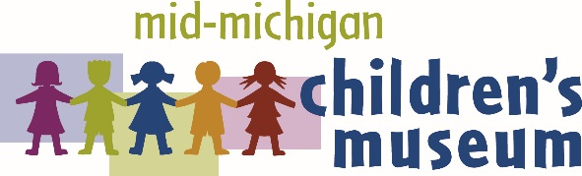
MEDIA RELEASE

CONTACT: Emily Yeager, President & CEO
315 W. Genesee Ave. I P.O. Box 2283
Saginaw, MI 48605
(989) 399-6626
eyeager@michildrensmuseum.com

Play like a kid at the Mid-Michigan Children’s Museum’s
Arts from the Heart Fundraiser and Auction
SAGINAW, MI – January 26, 2017: Adults can play like kids at the Mid-Michigan Children’s Museum’s 10th annual Arts from the Heart fundraiser and auction on Thursday, February 9. From 6 to 9 p.m. in the museum galleries, guests may place bets on the Minnow Races, play Craft Beer Pong or join the popular Wine Wobble. Tasty cupcakes, hearty hors d’oeuvres from the Bavarian Inn Restaurant and adult beverages are all included in the $50 ticket.
Robert Lee Revue will provide jazzy mood music while guests bid on a variety of silent auction items – including NASCAR tickets, sports memorabilia, jewelry, pampering packages, toys and art from local artists. The live auction, led by auctioneer Marty Wegner, will have fun kids-song-themed items not found anywhere else, such as:
- How Much is that Doggy in the Window – Snag this pet adoption package including an adoption waiver, check-up, spay or neuter, and microchip from Saginaw County Animal Care Center, as well as a grooming certificate, treats, shampoos and vitamins.
- Be our Guest – Enjoy a home-cooked meal for 6 prepared by chefs Senator Ken Horn, Associated Builders and Contractors CEO Jimmy Greene and WSGW host Art Lewis. All groceries and clean-up are included!
- Sing a Song of Flowers – Add a Susie McColgan masterpiece to your art collection with a custom poppy painting. You get to choose the colors and she will create a one-of-a-kind work of art.
Three specialty raffles will feature elegant gold jewelry from Diamonds and Jewelry Unlimited, a golf package at Apple Mountain, and the ever-popular Cellar Full of Wine.
Leading event sponsors Garber Management Group and Covenant HealthCare and media sponsor Alpha Media encourage guests to bid high to sustain the Mid-Michigan Children’s Museum galleries and enhance interactive Play and Learn experiences for Great Lakes Bay Region children.
View a complete list of sponsors and auction items on the MMCM Facebook page www.facebook.com/MiChildrensMuseumArtsfromtheHeart, purchase tickets online at www.michildrensmuseum.com/arts-heart-tickets/, or contact MMCM at (989) 399-6626. Members and volunteers can buy one ticket and get one free. Tickets will also be sold at the door the night of the event.
# # #
About the Mid-Michigan Children’s Museum
The Mid-Michigan Children’s Museum is a local 501(c)(3) nonprofit organization dedicated to providing a hands-on, Play and Learn environment that inspires children to use their curiosity and creativity to learn about the wonders of our world. For more information, call (989) 399-6626 or visit michildrensmuseum.com.

