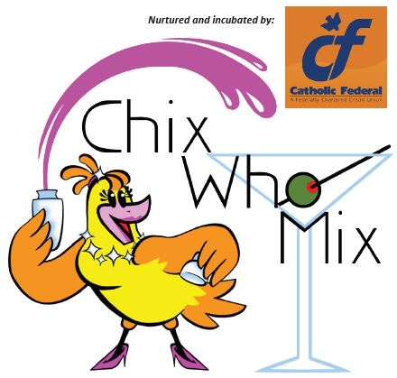
Media Release

Contact:
Emily Yeager, President & CEO
Mid-Michigan Children’s Museum
315 W. Genesee Ave. I P.O. Box 2283
Saginaw, MI 48605
(989) 399-6626
eyeager@michildrensmuseum.com

MIX IT UP WITH FINE FOOD, DRINKS AND GROOVY CHIX FOR LOCAL ARTS & CULTURE ORGANIZATIONS

Saginaw, MI – September 6, 2017: Four area arts & culture organizations are teaming up for the return of Chix Who Mix Thursday, September 21st from 5 - 7:30pm at your Mid-Michigan Children’s Museum (Saginaw). Local Chix will serve their signature cocktails, non-alcoholic fruit and fizzy drinks, wine, beer, and more. The $25 ticket includes beverage tasting and From Scratch Catering gourmet appetizers and is open to adults 21-years of age and older.

Once again Catholic Federal Credit Union presents this year’s Chix Who Mix event, which benefits the Mid-Michigan Children’s Museum, Saginaw Arts and Enrichment Commission, Saginaw Children’s Zoo, and the Saginaw Choral Society.

To sponsor Chix Who Mix, share your favorite drink, or purchase tickets to the event, call Saginaw Children’s Zoo at (989) 759-1408 or visit www.saginawzoo.com.

#####

About Mid-Michigan Children’s Museum
Mid-Michigan Children’s Museum is dedicated to providing a hands-on, Play and Learn environment that inspires children to use their curiosity and creativity to learn about the wonders of our world.

About Saginaw Arts and Enrichment Commission
The Commission provides programs and services which address areas such as: access to arts and cultural opportunities for at risk youth, arts education, audience development, diversifying and leveraging funding sources, and economic development.

About Saginaw Children’s Zoo
With more than 10 acres of beautiful tree-filled parkland, animal exhibits, exciting events, colorful gardens, miniature train and the region's only hand-carved carousel, there's something for you at the Zoo!

About Saginaw Choral Society
The Saginaw Choral Society includes 85 volunteer singers from all walks of life throughout the Great Lakes Bay Region. Saginaw Choral Society regularly collaborates with regional high school and college choirs, arts organizations and nationally renowned artists performing a diverse repertoire ranging from classical masterworks to Broadway and popular favorites. Come sing with us!

